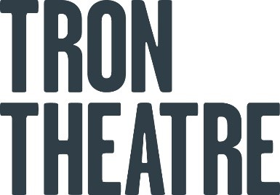 MAKING SPACE | TRON CREATIVE
Making Space is Tron Theatre’s offer of in-kind space to artists who need it. You might be looking for a room to rehearse in, some R&D time or just space for brainstorming. Whenever we have room available, it’s yours to use free of charge.
Making Space takes place either in the Vic or the Changing House, with the rooms available from 10.30am - 5.30pm. Dates are currently available from Dec 2022 – Mar 2023.
The Making Space offers comes with no tech support and cannot include any public output (i.e. a sharing). Otherwise, it’s yours to use as you please.
Making Space is offered on a first come, first served basis and we ask that artists request no more than three days at a time. To request space, please fill out this short online form.

THE VIC
The Vic contains:
- Tables
- Chairs
- A rollable PA
- Paper and pens left out for you
Lights can be found on the left-hand side of the room, just behind the old bar.
The nearest toilets are in the bar – exit the Vic and turn to your right.
Fire exit:
- Primary route – Parnie Street exit
- Secondary route – yellow brick road
- Please study the evacuation route that can be found attached to the internal doors of the space

CHANGING HOUSE
The Changing House contains:
- Tables
- Chairs
- A rollable PA
- Paper and pens left out for you
Lights can be found on the left-hand side of the room, just as you enter the space.
The nearest toilets are downstairs – exit the Changing House, go down the stairs and turn right before you enter the Box Office.
Fire exit:
- Primary route – yellow brick road
Secondary route – auditorium entrance
- Please study the evacuation route that can be found attached to the internal doors of the space

TO OPERATE THE TABLES:
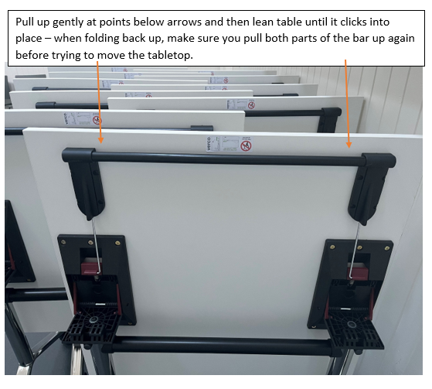

Please leave the room as you found it! There are often workshops in the evenings. 😊
Any questions: creative@tron.co.uk

