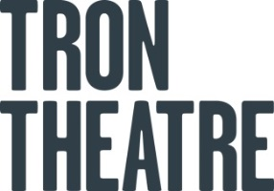
Work Placement Application Form [2017-18]

Name: D.O.B:
Course studying: Year:
Institution: Course Leader:
Placement applying for (please mark with X)
Technical Stage Management Facilitation
Length of placement applicant is looking for:
*Please note we can only host a limited number of placements from September – July each year.

Background / Education – Tell us about your relevant experience.

Why do you want to gain work experience at the Tron Theatre?

Signed: Date:
- Please email your application form and C.V to info@tron.co.uk no later than Friday 6th October 2017.
- Please put ‘work placement’ in the subject line to ensure your application can be directed to the correct department.
- Due to volume of applicants, if we do not reply within 28days we do not have any relevant opportunities for you.
- If we do get back to you within 28days you will be asked to attend an interview with the relevant department.
- Gaining an interview does not guarantee you a work placement.

