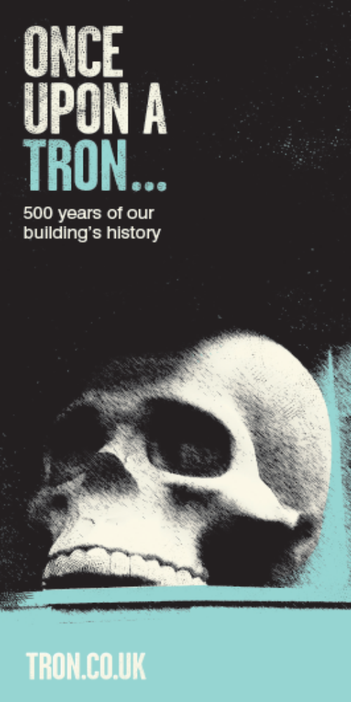

WHY ‘TRON’?

Prior to the 17th century, the gate around St Enoch Square was known as St Tennoch’s Gate. It was the hub of Glasgow’s trade and a vital meeting point for merchants. Ships would dock along the Clyde and their goods would be transported to the area around Glasgow Cross to be weighed. A ‘trone’ was a large beam for weighing goods entering Glasgow’s city walls. Over time the necessity of the trone declined until it was removed completely but the area retained the name Trongate.

ADAM’S GALLERY

There was originally a balcony in the main nave of the 1795 Tron Church named after the architect James Adam. During the conversion of the Main Auditorium in the 1980s this was removed and donated to the People’s Palace in Glasgow.

MIRROR, MIRROR ON THE WALL

The Tron Mirror hangingin the Victorian Bar today was the only specially commissioned piece to celebrate the opening of the Victorian Bar in 1981. The Glasgow Theatre Club relied on donations of fixtures and fittings to fill the space, including the gantry of the bar, which was rescued from a pub in Govan. The gantry is what gives the bar its name, but it is unclear whether this is because of the style it is made in or the name of the bar it was rescued from.

HELL HATH NO FURY

On 15th February 1793, a notorious group known as the Hell Fire Club set fire to the old Tron Kirk. These were men of high standing who could perform immoral acts in the city. Their motto was ‘Fay ce que vouldras’ or ‘Do what thou wilt’.

After much bravado, they decided to stoke up the night watchmen’s fire to see how much heat each could withstand. After creating a huge fire, they could no longer endure the heat and fled from the church. Despite their intentions being harmless, the building was set alight and destroyed, with only the Steeple surviving…Unfortunately all records for the church were held within its grounds; no evidence remains of its design.

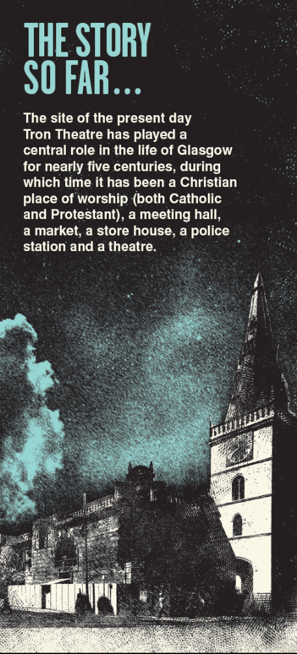

1525

Collegiate Church of St Mary of Loretto and St Anne established by James Houston (Sub Dean of Glasgow).

1560

Catholicism outlawed in Scotland.

1592

Town Council order the site to become a Protestant Church, the Laigh Kirk (New Kirk), with John Bell appointed first Protestant minister.

1593

Steeple built.

1636

Spire added to Steeple to make building look more like a Protestant church.
‘In the most best and commodious forme that can be devisit by the best craftsmen…’

1793

Notorious Hell Fire Club burn down original church building.

1795

James Adam designs and builds the new Tron Church (Steeple only original feature to survive the fire).

1800

Glasgow’s first police force use the Tron’s session house as a meeting place.

1821

Tron Steeple clock is the first in Britain to be illuminated with gas reflectors, the invention of a Glasgow pastry baker, John Hart.

1855

Arches added under Steeple to allow for increased pedestrian traffic on the pavement (designed by Glasgow’s first appointed City Architect, John Carrick).

1899-1900

A railway ventilation shaft is built with a curtain wall on the corner of Chisholm Street and Trongate, now known as Burnet Wall.

1946

Tron Church ceases to be a place of worship.

1949-1978

Tron Church falls in to disrepair through misuse as a workshop.

1978

Glasgow Theatre Club formed in April

1979

Glasgow Theatre Club leases the Tron Kirk

‘…to provide opportunities for local writers and actors, to widen the choice for theatre-goers, and to make the Tron the most accessible and welcoming venue in Glasgow…’

1980

Glasgow Theatre Club move into the Tron on 1st January.

1981

First performance takes place in the Victorian Bar.

1982

The Main Auditorium is completed and opened.

1990

Tron becomes a public building and not exclusive to Theatre Club members.

1992

Adam’s Gallery from Church donated to People’s Palace and Dome in Main Auditorium uncovered.

1996

A £5million refurbishment programme begins.

1997

A new custom designed Box Office building is opened. Kenny Hunter commissioned to create sculptures Cherub/Skull for building exterior.

1998

Admin office opened in July.

1999

The fully refurbished Tron Theatre re-opens.

2008

Box Office moves to current location.

2011

The Tron Theatre celebrates 30 years of performances.

SAINTS, SKULLS & CHERUBS…
ST MUNGO’S SCULPTURE

On the west-facing wall of the Tron Steeple is a sculpture of St Mungo, the patron saint of Glasgow. It was designed and contructed by Sharmanka in 2001, a local company who specialise in kinetic sculpture design. The sculpture is activated on the hour when the steeple bell tolls. A small bird pecks, a fish spins and St Mungo raises his staff. The bell, bird and fish are all emblems of Glasgow and feature on its coat of arms.

CHERUB & SKULL
Cherub/Skull is a pair of bronze sculptures installed on the exterior of the Tron Theatre. The Cherub stands prominently on Trongate above the Burnet Wall. Skull is on the opposite corner of the building tucked away in a niche on the second floor wall on Parnie Street. Designed by Kenny Hunter and installed in 1997, Cherub/Skull was commissioned as a unified sculptural statement to represent the building both as a place of worship and as a theatre.

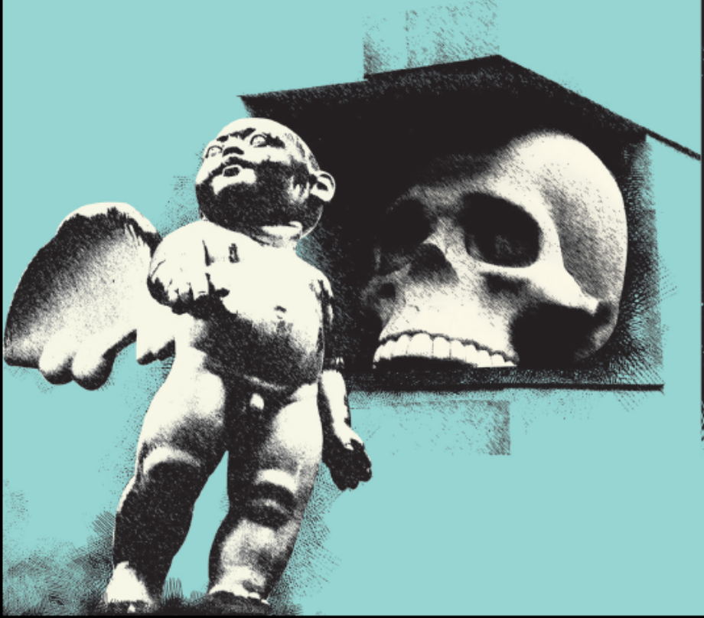

THINGS THAT GO BUMP IN THE NIGHT…
Since the arrival of the Glasgow Theatre Club, several paranormal groups have conducted investigations in the building. Many spooky tales and ghostly sightings have also been reported.

In 1899 during the construction of a new underground line, builders uncovered corpses buried in the old Tron church graveyard. The Tron also acted as a holding building for condemned men who were taken by an underground tunnel that still exists beneath the building, to be hung at Glasgow Cross. Many men died of heart attacks before they reached the Cross.

On several occasions a hooded figure has been seen walking at the back of the Victorian Bar. A previous member of bar staff experienced something that defies explanation:

‘I was leaning against the bar when I heard a faint hiss coming from behind my head. The sound became louder and louder and started to sound like the work ‘No’. This carried on for a few minutes. I moved around the bar to see if it was where I was standing, but the sound followed me everywhere and seemed only to be inches away from my ear. Then all of a sudden the noise stopped, something hit me across the back of my knees…and it was gone.’

There have been numerous sightings of small girl, Lily, staring out of the window on the east stairwell. According to witnesses, the sightings are preceded by a strong smell of leather. If accounts from paranormal investigators are to be believed, Lily was fatally wounded by a horse-drawn cart on the Trongate and taken into the church, where she passed away.

HOW TO BOOK

ONLINE tron.co.uk
CALL 0141 552 4267
TEXT 18001 0141 552 4267
TABLE RESERVATIONS 0141 552 8587
IN PERSON at our Box Office
63 Trongate, Glasgow G1 5HB

facebook.com/trontheatre
twitter.com/trontheatre

BOX OFFICE
MON - SAT 10AM - 6PM
Extended on performance evenings to 15 minutes after our last performance starts

SUNDAY
Two hours before the first performance starts otherwise closed

For details of our reservations policy, a full list of the concession types we accept, access arrangements at the venue, or our Terms and Conditions of booking please visit www.tron.co.uk

BAR & KITCHEN
MON - SAT 10AM - late
SUN 12pm -6pm
ACCESS
The Tron Theatre is committed to being an accessible venue and our public areas are fully accessible for those with limited mobility. Facilities include ramps, elevators, adapted toilets and auditorium seating. In addition we’re committed to programming Audio Described, Signed and Captioned performances. Details of these can be found on show listings. Please do let us know if you have any specific access requirements and we will do our utmost to accommodate them.

SUPPORT
The Tron gratefully acknowledges support from:

FUNDERS
Creative Scotland, Glasgow City Council

SPONSORS
Ancnoc, Belhaven Best
CORPORATE PARTNERS
AFS, Alliance Wine, DPI Broadway, EVM, JamHot, Kopparberg, Millennium Hotel Glasgow, West, Robertson Taylor W&P Longreach

If you are interested in playing a vital role in the Tron’s future call 0141 559 5304. Tron Theatre Ltd is a Scottish Registered Charity No: SCO12081

